Assignment 1

Prep by: Prasad Swami_AC

1.1
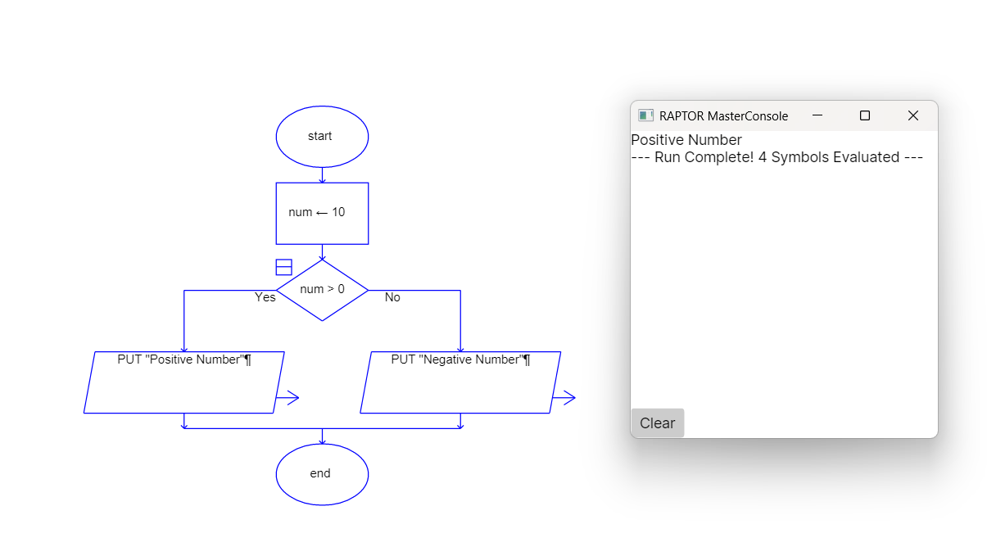
Code:
class PositiveNum{
public static void main(String args[]){
int num = 10;
if(num > 0){
System.out.println("Positive Number");
}else{
System.out.println("Number is not positive");
}
}
}

1.2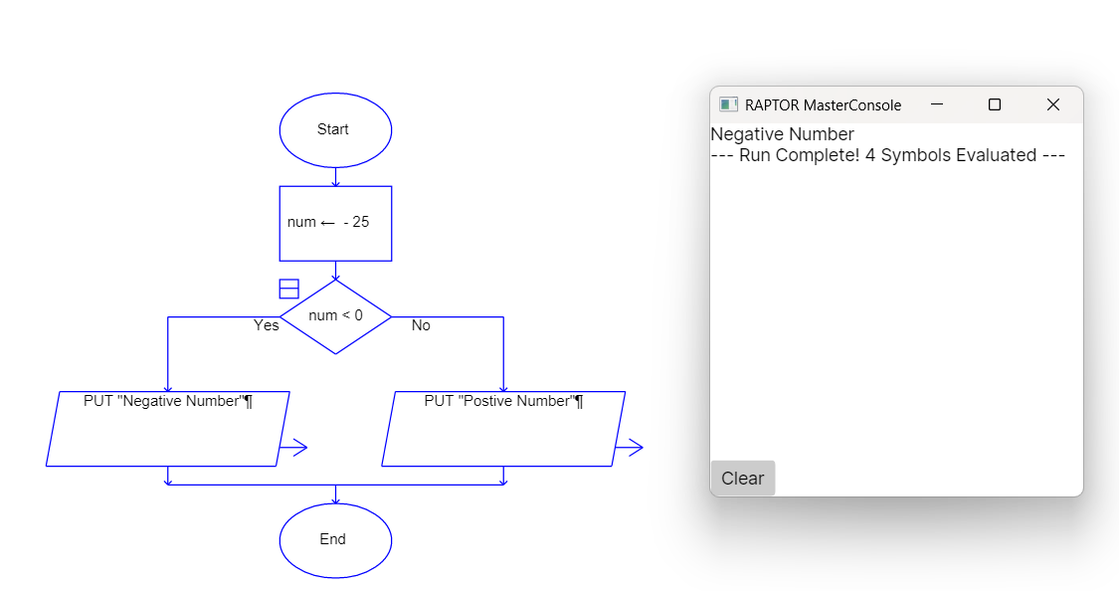

class NegativeNum {
public static void main(String args[]){
int num = -25;
if (num < 0){
System.out.println("Negative Number");
}else{
System.out.println("Number is not negative");
}
}
}

1.3
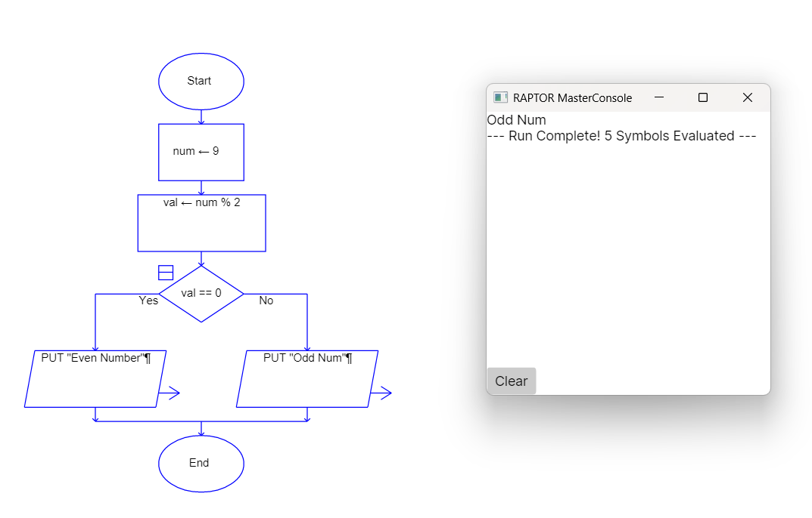
class EvenOdd{
public static void main(String args[]){
int num = 9;
int val = num % 2;
if (val == 0){
System.out.println("Even Number");
}else{
System.out.println("Odd Number");
}
}

}

1.4
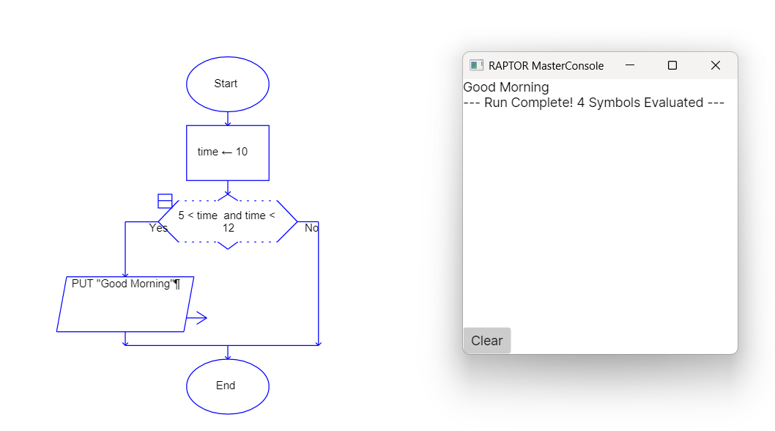
class GoodMorning {
public static void main(String args[]){
int time = 10;
if(5<time && time<12){
System.out.println("Good Morning");
}
}
}

1.5
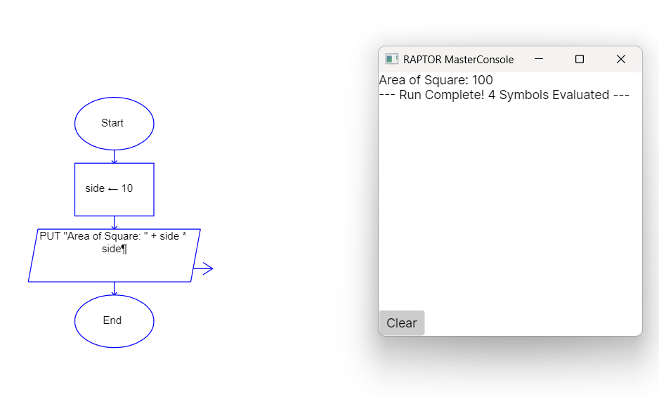
class AreaofSquare {
public static void main(String arga[]){
int side = 10;
System.out.println("Area of Square: "+ (side*side));
}

}

1.6
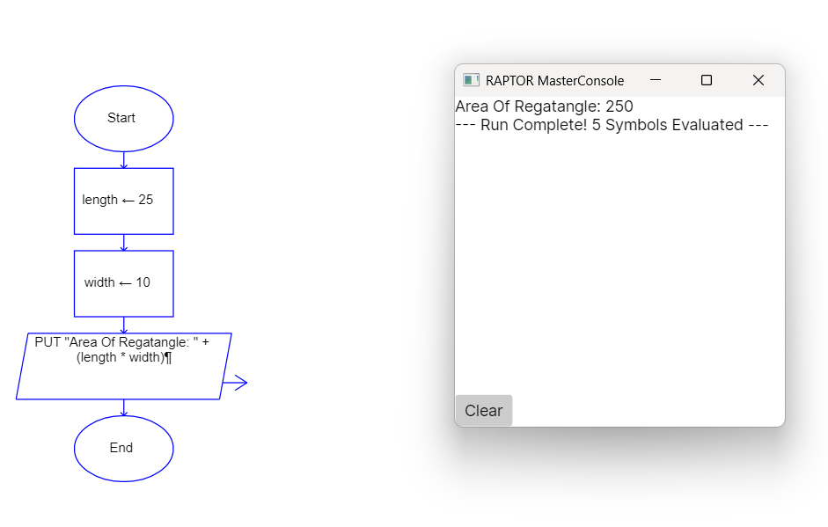
class AreaofRegatangle {
public static void main(String args[]){
int length = 25;
int width = 10;
System.out.println("Area of Regatangle: " + (length * width));
}

}

1.7
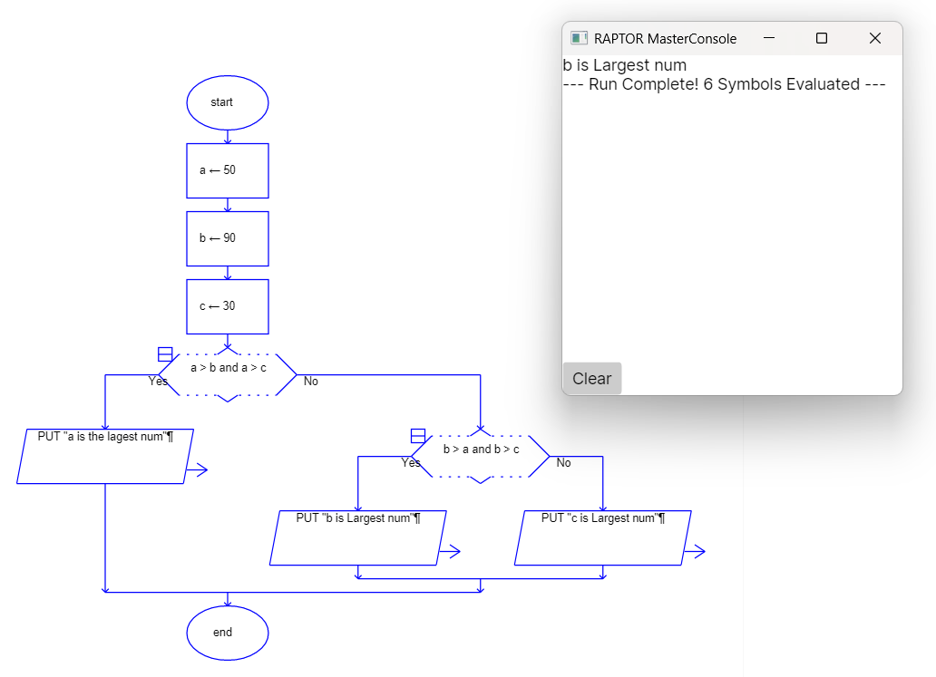

class LargestNum {
public static void main(String args[]){
int a = 50;
int b = 90;
int c = 30;
if (a > b & a > c){
System.out.println("a is the Largest num");
}else if(b > a & b > c){
System.out.println("b is the Largest num");
}else{
System.out.println("c is the Largest num");
}
}
}

